Lab 6: Access control vulnerabilities - IDOR
Objective:
- We will explore the concept of Insecure Direct Object References (IDOR) and understand how it poses a significant security threat to web applications.
In this lab, students need to:
- Answer the following questions:
  - What is an Insecure Direct Object Reference (IDOR), and how does it present a security risk in web applications?
  - How can attackers exploit IDOR vulnerabilities in a website, and what are some common techniques used in such attacks?
  - What types of functionality or data in a website can be affected as a result of an IDOR vulnerability being exploited?
- Perform challenge:
  - Insecure direct object references
- Explain and capture all steps (full windows screen capture).

Submit a report addressing all the questions mentioned above in either PDF or Markdown format. Additionally, include a video demonstrating the detailed process of your work to ensure the authenticity of your lab exercise.
The report file name must be Class_YourStudentID _YourName_Lab6

Insecure direct object references

This screenshot shows Burp Suite capturing HTTP requests while the user browses the shopping site in the IDOR lab. Each time a product action is performed, the browser sends requests that likely contain object identifiers such as product IDs. These IDs are visible in the traffic and may be directly trusted by the server. This indicates a potential Insecure Direct Object Reference vulnerability, where modifying an ID could allow access to unauthorized resources.
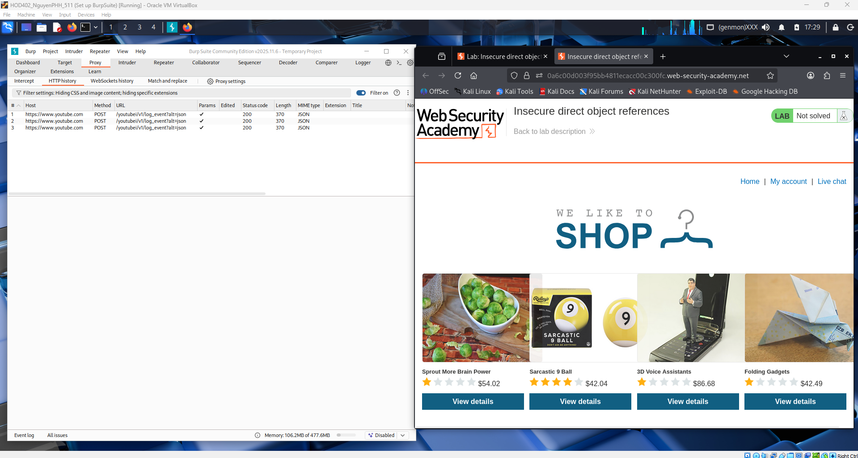

Here Burp Suite is intercepting traffic when accessing the Live chat feature in the IDOR lab. The request to the server includes a chat-related object (such as a transcript or chat ID) that is handled through a direct reference in the URL or parameters. Because these identifiers can potentially be changed, an attacker may access other users’ chat data without authorization. This demonstrates how IDOR occurs when the server does not properly verify whether the user is allowed to access the requested object.
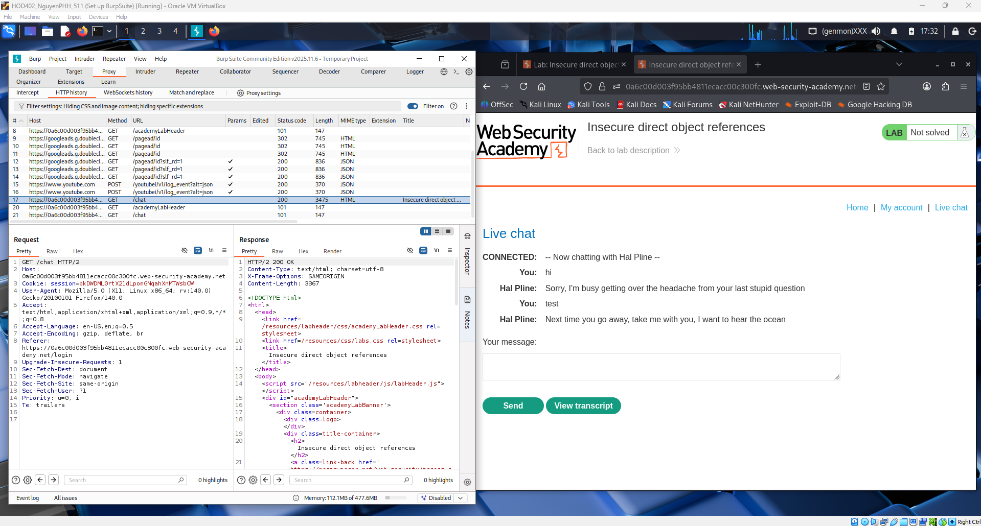
In this screenshot, Burp Suite captures a POST request to /download-transcript triggered by the “View transcript” button in the live chat. The request includes an identifier that directly references a specific transcript file on the server. Because this value is not protected or tied to the logged-in user, it can be modified to access other users’ transcripts. The server still responds with 200 OK and returns the file, showing that no proper authorization check is performed. This behavior confirms an Insecure Direct Object Reference (IDOR) vulnerability, where sensitive resources are exposed through predictable identifiers.
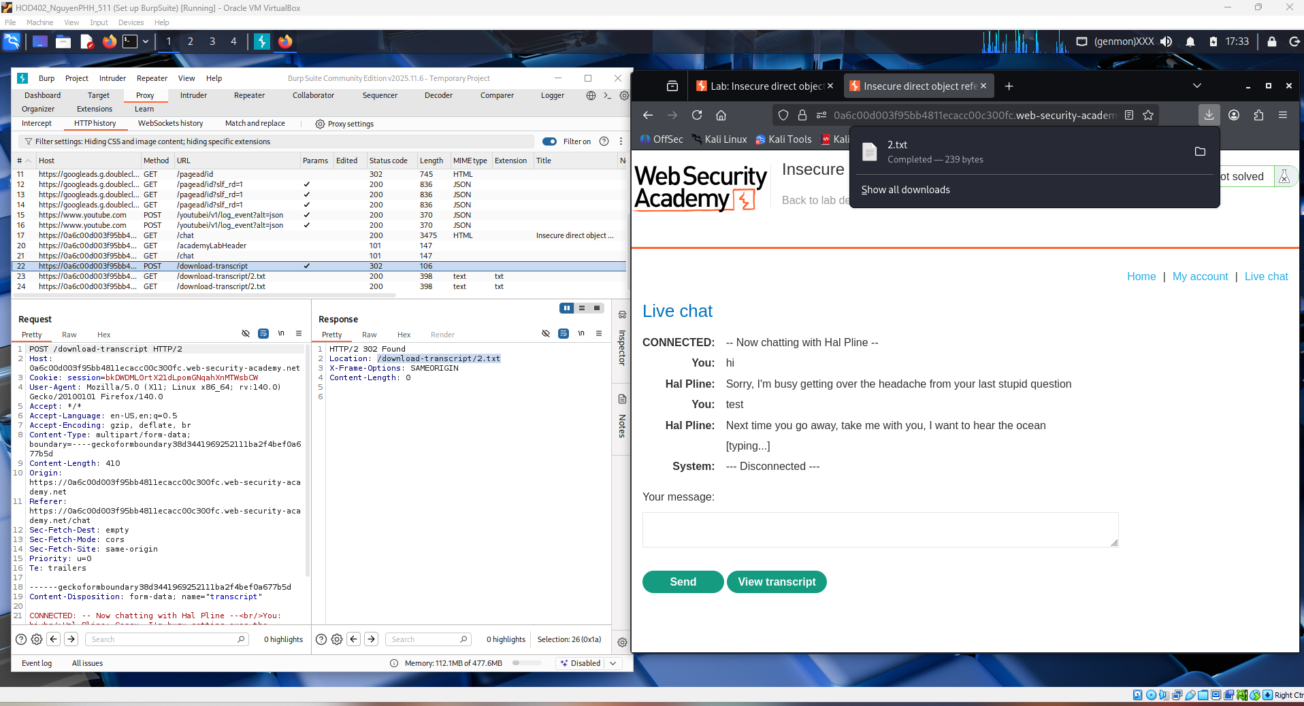
This image shows the IDOR exploitation more clearly. In Burp, the request is changed to GET /download-transcript/2.txt, directly guessing another transcript filename. The server still returns 200 OK and sends back the full chat conversation in plain text, even though this file should belong to a different session/user. This proves the application only relies on the file name in the URL and does not verify user authorization. As a result, attackers can enumerate transcript IDs and download other users’ private chat logs — a classic Insecure Direct Object Reference issue.
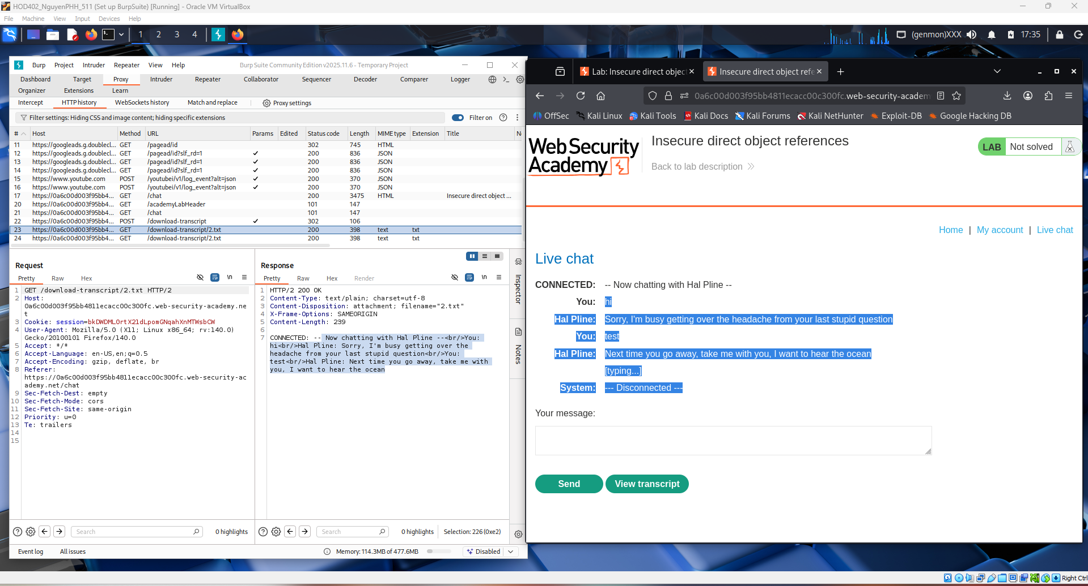
Here you moved the attack into Burp Repeater to manually test the object reference. The request GET /download-transcript/2.txt is being sent directly to the server without using the normal website buttons. Even though you are just a regular logged-in user, the server still responds with 200 OK, meaning access is granted. This confirms the transcript file is accessed purely by changing the number in the URL, with no access control check. That behavior demonstrates the core IDOR flaw: direct object access based only on predictable identifiers.
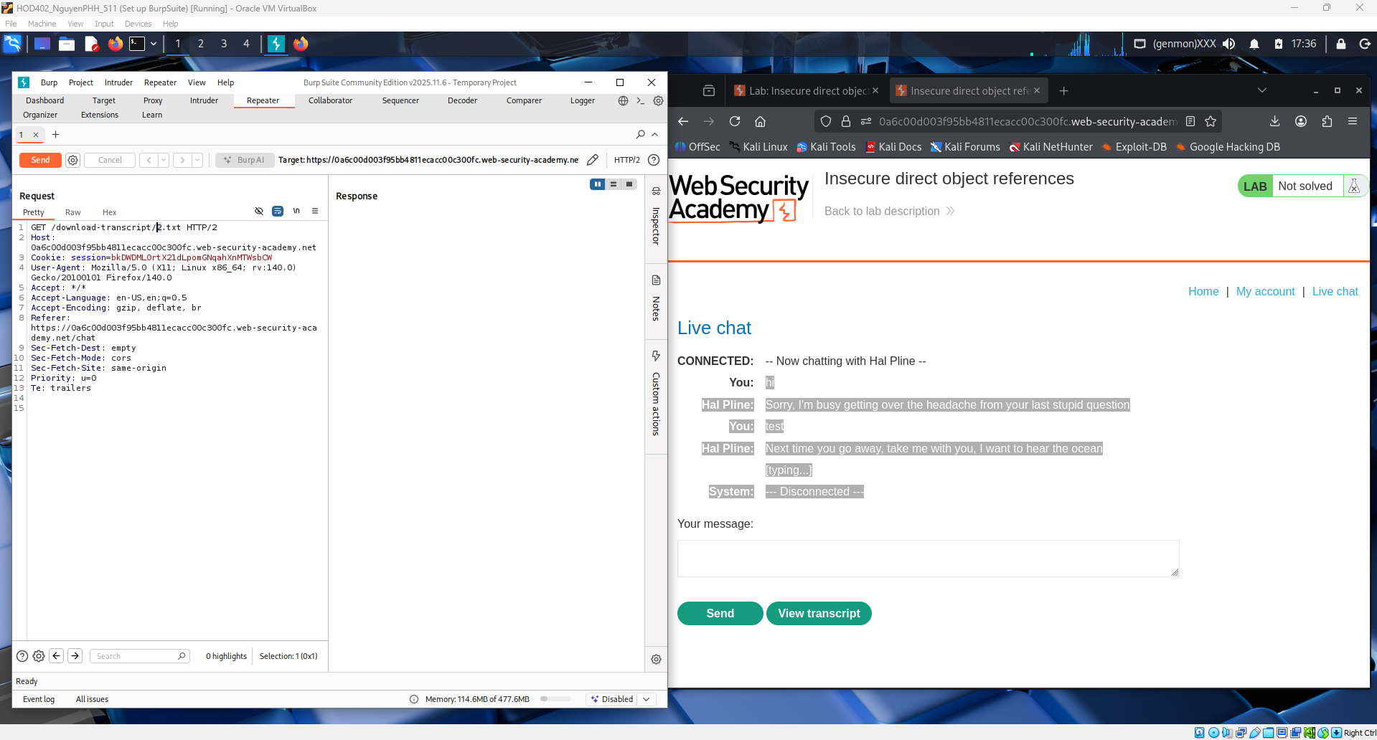
This screenshot shows the successful exploitation of the IDOR. In Burp Repeater, the request GET /download-transcript/1.txt returns 200 OK and the full chat transcript file. The response contains sensitive conversation data, including Hal Pline discussing password reset information, which should not be accessible to another user. This proves the application does not verify ownership before serving files. Changing only the numeric ID in the URL exposes other users’ private data — a classic Insecure Direct Object Reference vulnerability.
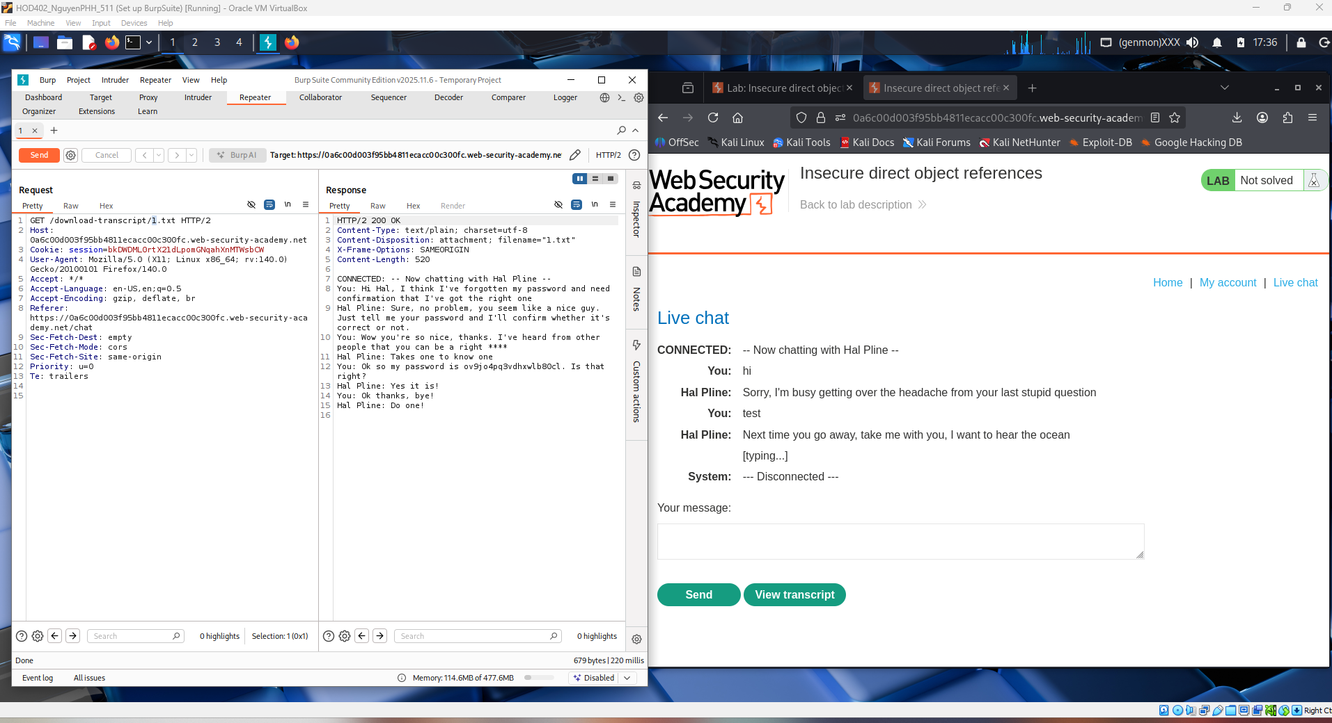

This screenshot is the final proof of the IDOR vulnerability in the lab.
In Burp Repeater, the request GET /download-transcript/1.txt successfully retrieves another user’s chat transcript. The response contains sensitive conversation data, including a message where Hal Pline reveals his password. This shows the application allows direct file access based only on the numeric ID in the URL, with no authorization check.
The PortSwigger lab description on the right confirms that chat logs are stored on the server and accessed via static URLs. By simply changing the object reference (the file number), we can read other users’ private data — a clear access control failure and a classic Insecure Direct Object Reference (IDOR) vulnerability.
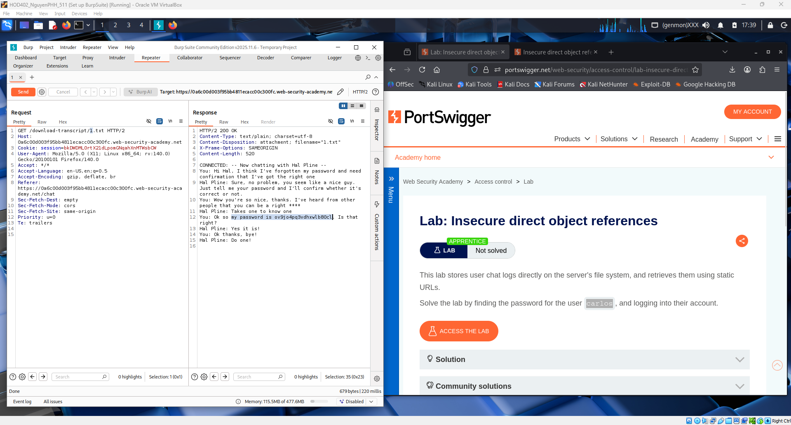

In this lab, I exploited an Insecure Direct Object Reference (IDOR) vulnerability. By intercepting a request in Burp Suite and changing the URL to /download-transcript/1.txt, I accessed another user’s private chat file without authorization.
The transcript revealed the password of the user carlos, showing a failure in access control. I used these credentials to log into his account, proving the vulnerability can lead to information disclosure and account takeover.
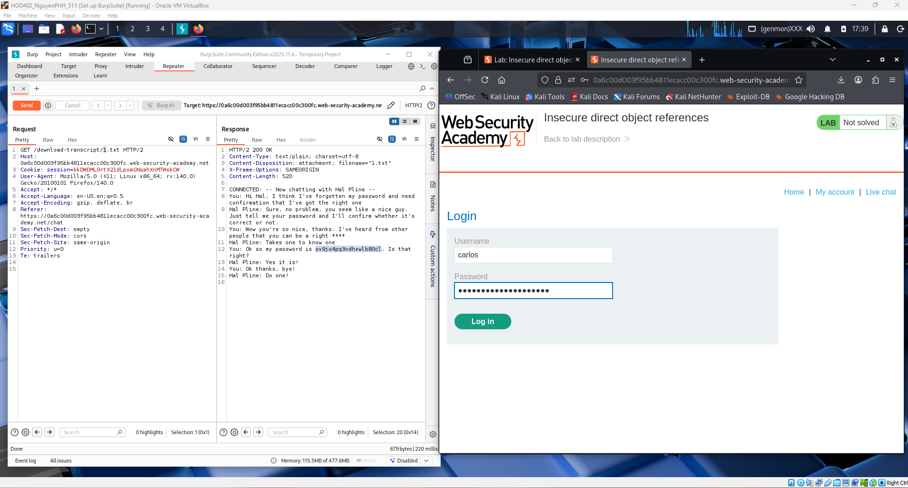

Using Burp Suite, the request to /download-transcript/1.txt was intercepted and modified, allowing access to another user’s chat transcript. The server responded with a plaintext file containing private conversation data. Within this transcript, sensitive information was disclosed, including Carlos’s password, which should not be accessible to other users.
This confirms that the application retrieves files directly based on a numeric identifier in the URL without performing proper authorization checks. Because object access is controlled only by changing the file reference, an attacker can enumerate and access other users’ data. This represents a clear access control failure and is a classic example of an Insecure Direct Object Reference (IDOR) vulnerability.
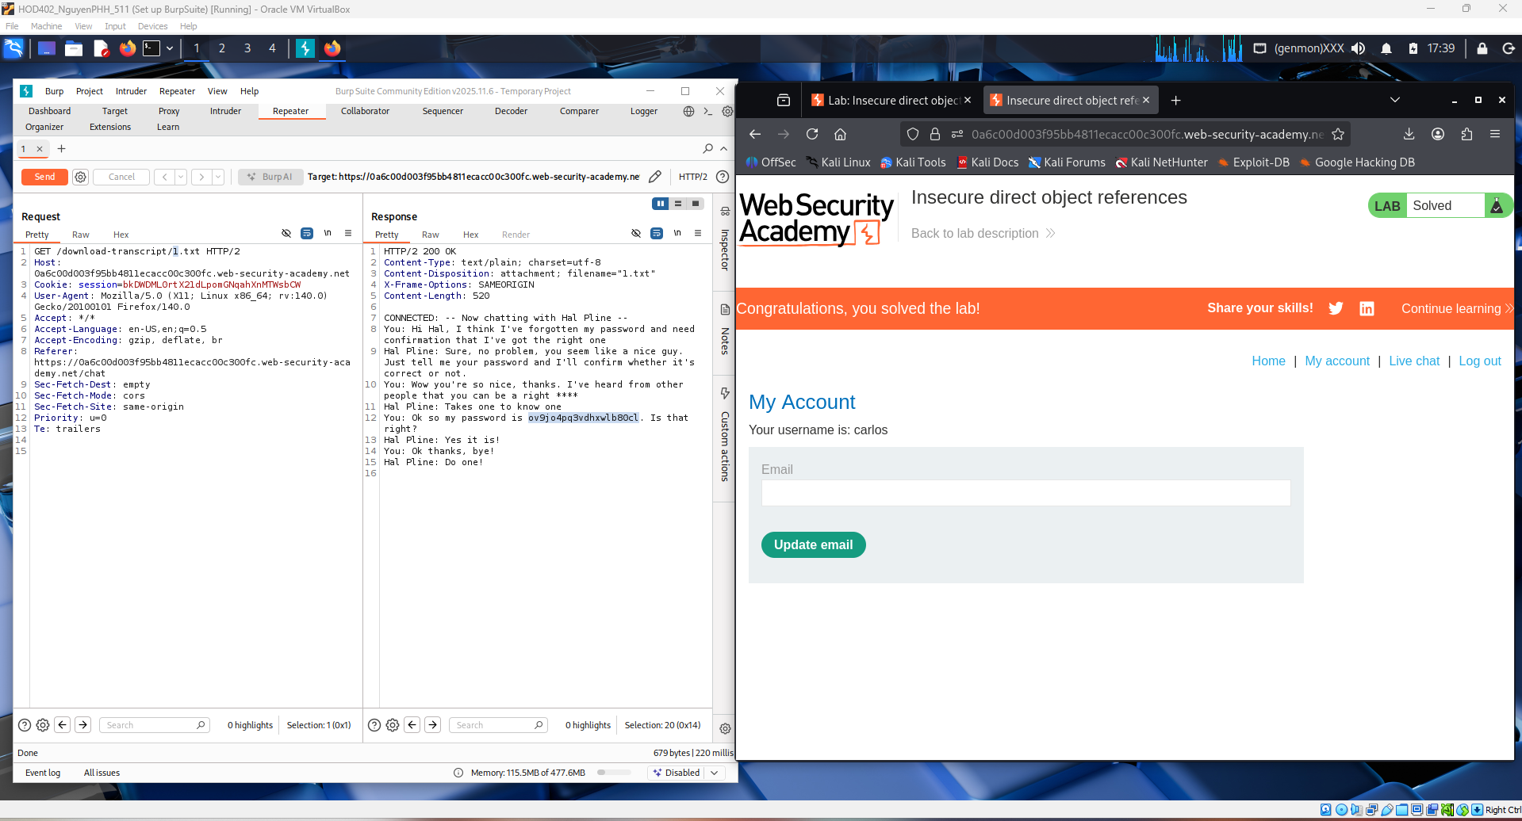

Conclusion Insecure Direct Object Reference (IDOR):
This lab demonstrates how improper access control can expose sensitive user data through predictable object references. By manipulating the file ID in the request, unauthorized chat transcripts were retrieved, ultimately revealing a valid user password. The application failed to verify whether the requester was authorized to access the resource, allowing direct access to internal files.
The attack highlights the risk of relying on user-supplied identifiers without server-side authorization checks. This vulnerability is a textbook Insecure Direct Object Reference (IDOR) and shows why access control must be enforced on every request. Proper mitigation includes implementing strict authorization validation and avoiding direct exposure of internal file paths.

